Grade: High School | Course: World History & Geography
Decolonization and Understanding the Contemporary World
Week of May 11th, 2020
Standard(s)
W.73 Describe how competing national, ethnic, and religious interests led to conflict and the establishment of new countries in the Balkans.
W.75 Explain the causes and effects of German reunification on both West and East Germany.
W.76 Analyze the response of Arab countries to the creation of the State of Israel and the peace processes in the Middle East, including the Camp David and Oslo Accords.
W.77 Analyze the demographic changes of countries in post-World War II regions, using population pyramids and census data.
W.78 Explain the challenges of rapid population growth on developing countries (e.g., China and India) and of population decline in developed countries (e.g., Germany, Japan, and Sweden), and give examples of policies implemented to both slow and increase population growth. C, E, G, H, P
W.79 Describe the cultural, economic, geographic, and political effects of significant technological, ideological, medical, and scientific developments and breakthroughs of the era.
W.83 Explain the goals and consequences of trade organizations and treaties and how they have played a role in the growing global economic system. E, G, H, P
W.84 Identify examples of supranational organizations, and discuss the benefits and drawbacks of membership.

Day 1
Focus 1: Cold War Review

Task 1- Complete the outline of the Cold War
The Cold War
- An Overview
- The Initial Rift
- _______________________________________________________________
- The Common Threat
- _______________________________________________________________
- The Starting Date
- _______________________________________________________________
- The Superpowers
- _______________________________________________________________
- The Initial Arena
- _______________________________________________________________
- Rival Military Alliances
- _______________________________________________________________
- The Iron Curtain
- _______________________________________________________________
- Globalizing the Conflict
- _______________________________________________________________
I. Korean War
1. _______________________________________________________________
J. Vietnam
1. _______________________________________________________________
K. Afghanistan
1. _______________________________________________________________
L. Castro
1. _______________________________________________________________
M. Cuban Missile Crisis
1. _______________________________________________________________
N. An Arms Race
1. _______________________________________________________________
O. India and Nonalignment
1. _______________________________________________________________
P. Indonesia
1. _______________________________________________________________
Q. Egypt
1. _______________________________________________________________
R. “Imperial Presidency”
1. ______________________________________________________________
S. “Military Industrial Complex”
1. _______________________________________________________________
T. Flourishing U.S. Economy
1. _______________________________________________________________
II. The Soviet Union, China, and the Communist World
- Death of Stalin
- _______________________________________________________________
- Nikita Khrushchev
- _______________________________________________________________
- Government Propaganda
- _______________________________________________________________
- Yugoslav Leaders
- _______________________________________________________________
- Hungary and Czechoslovakia
- _______________________________________________________________
- Poland
- _______________________________________________________________
- Soviet Union and China
- _______________________________________________________________
- “Triangular Diplomacy”
- _______________________________________________________________
- More Divisions within Communism World
- _______________________________________________________________
- Death of Mao Zedong
- _______________________________________________________________
- Mikhail Gorbachev
- _______________________________________________________________
- Glasnost and Perestroika
- _______________________________________________________________
- Two General Failures of Communism
- _______________________________________________________________
- A Changing Communism
- Deng Xiaoping
- _______________________________________________________________
- _______________________________________________________________
- Opening China to the World Economy
- _______________________________________________________________
- Responses to Democracy Movements
- _______________________________________________________________
- Tiananmen Square
- _______________________________________________________________
- Gorbachev
- _______________________________________________________________
- _______________________________________________________________
- Comparisons to China
- _______________________________________________________________
- Collapse
- _______________________________________________________________
- Rise of Nationalist Movements
- _______________________________________________________________
- 1989
- _______________________________________________________________
- The Fall of the Soviet Union
- _______________________________________________________________

Day 2
Focus 1: Cambodian Genocide

Task 1- Use the link below and read the article. Then, answer the questions below.

https://worldwithoutgenocide.org/genocides-and-conflicts/cambodia

1: List the date of the Cambodian Genocide.
2: Describe the events of the genocide.
3: How is the genocide linked to the Vietnam War?
4: List and summarize the cause and effects of the genocide.

Day 3
Focus 1: Benefits of Globalization

Task 1- Watch the video and answer the questions below.
https://www.youtube.com/watch?v=5SnR-e0S6Ic&list=PLBDA2E52FB1EF80C9&index=42&t=0s

1: Explain the complexities of economic globalization
2. What are some of the benefits of economic globalization
3. Why has migration become so easy?

Day 4
Focus 1: Supranational organizations

Task 1- Read the excerpts and answer the questions that follow:

Excerpt adapted from the bbc.co.uk
“The G8 is an informal grouping of the world's seven richest industrial countries - the United States, Japan, Germany, France, Britain, Italy, Canada - whose leaders have been meeting regularly since 1975 in an annual summit to discuss problems in the world economy - plus Russia, which joined more recently.
The summits initially focused on economic problems, such as the oil crisis, but more recently the agenda has broadened out to include development, environment, and global security issues.
The group of eight countries makes up more than half of the total world economy.
The group was originally known as the G7.
In 1991, following the collapse of communism, Russia was admitted as an observer to the meetings; in 1994 it became a formal member of the non-economic part of the summit, and in 1998 it became a full member of the G8…

The summits began when the world was facing the first oil crisis which had pushed the world into recession, and this year there will again be talk of managing the global recovery and driving forward a free-trade agenda. However, the annual summit has evolved over the years to include other topics such as the environment, money laundering, and global terrorism.”

1- What countries belong to the G8? _________________________________________________________________
2- What is the purpose of the G8? _________________________________________________________________
3- What events led to Russia’s full membership in the G8? _____________________________________________

Excerpt adapted from imf.org
“The IMF was conceived in July 1944, when representatives of 45 governments meeting in the town of Bretton Woods, New Hampshire (USA)…agreed on a framework for international economic cooperation. They believed that such a framework was necessary to avoid a repetition of the disastrous economic policies that had contributed to the Great Depression of the 1930s.

During that decade, attempts by countries to shore up their failing economies—by limiting imports, devaluing their currencies to compete against each other for export markets, and curtailing their citizens' freedom to buy goods abroad and to hold foreign exchange—proved to be self-defeating. World trade declined sharply, and employment and living standards plummeted in many countries.

Seeking to restore order to international monetary relations, the IMF's founders charged the new institution with overseeing the international monetary system to ensure exchange rate stability and encouraging member countries to eliminate exchange restrictions that hindered trade. The IMF came into existence in December 1945…Since then; the IMF has adapted itself as often as needed to keep up with the expansion of its membership…and changes in the world economy…

The IMF's membership jumped sharply in the 1960s, when a large number of former colonial territories joined after gaining their independence, and again in the 1990s, when the IMF welcomed as members the countries of the former Soviet bloc…”

“The IMF works both independently and in collaboration with the World Bank to help its poorest member countries build the institutions and develop the policies they need to achieve sustainable economic growth and raise living standards…

Globalization, poverty, the inevitability of occasional crises in a dynamic world economy—and, no doubt, future problems impossible to foresee—make it likely that the IMF will continue to play an important role in helping countries work together for their mutual benefit for many years to come…”

- What factors led to the creation of the IMF? ________________________
- Why did membership in the IMF jump sharply in the 1960s and 1990s? ________________________
- What are the IMF’s goals? ________________________

Day 5
Focus: Contemporary Global Issues: Environmental Issues

Task 1- Read the following article and answer the questions below.

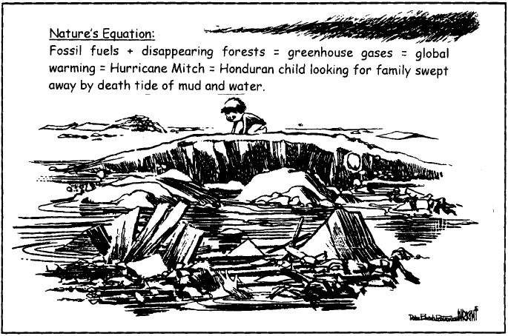
Excerpt adapted from epa.gov
“The Earth's climate has changed many times during the planet's history, with events ranging from ice ages to long periods of warmth. Historically, natural factors such as volcanic eruptions, changes in the Earth's orbit, and the amount of energy released from the Sun have affected the Earth's climate. Beginning late in the 18th century, human activities associated with the Industrial Revolution have also changed the composition of the atmosphere and therefore very likely are influencing the Earth's climate…For over the past 200 years, the burning of fossil fuels, such as coal and oil, and deforestation have caused the concentrations of heat-trapping "greenhouse gases" to increase significantly in our atmosphere. These gases prevent heat from escaping to space, somewhat like the glass panels of a greenhouse. Greenhouse gases are necessary to life as we know it, because they keep the planet's surface warmer than it otherwise would be. But, as the concentrations of these gases continue to increase in the atmosphere, the Earth's temperature is climbing above past levels…Climate change affects people, plants, and animals.”
Question: Analyze the political cartoon and the excerpt. According to these documents, what is global warming? Compare and contrast the documents. Which document suggests that global warming has very specific and dire consequences?

